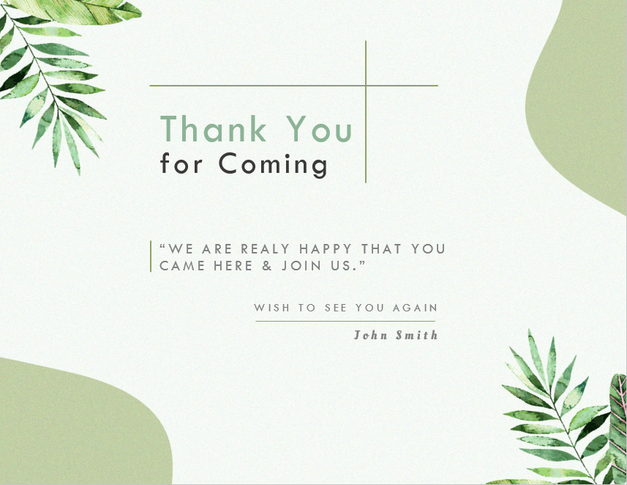
Thank You
for Coming
“WE ARE REALY HAPPY THAT YOU CAME HERE & JOIN US.”
WISH TO SEE YOU AGAIN
John Smith

