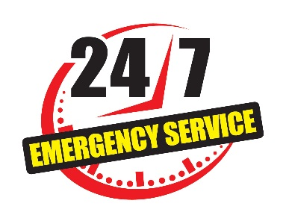
Emergency Call List
Emergency Service | Phone No. | Alternate No.
Police/Ambulance | 555-444-333 | 555-444-222
Fire Department | 555-444-333 | 555-444-222
Gas Company | 555-444-333 | 555-444-222
Electric Company | 555-444-333 | 555-444-222
Water Company | 555-444-333 | 555-444-222
Poison Control Center | 555-444-333 | 555-444-222
 | 


